Joshua Hoshiko

CS 3120

Dr. Jiang

Homework 1 Report

Note: Received assistance from Gerom Pagaduan with the code

**Program Overview:**

This program is designed to demonstrate the generation of a model using gradient decent. It creates a loss function landscape and generates random points to test the models ability to adjust and minimize loss.

1. The program first generates 10 data samples for testing
2. The program then generates the loss function’s landscape similar to a bowl. The values represent different values of loss, with the bottom of the bowl representing a minimal loss
3. The program then uses gradient decent to try various different values for the bias and the weight, adjusting at a chosen learning rate and “stepping” towards the bottom of the bowl. The FOR loop adaptation finishes once it has completed 10,000 iterations.
4. The program renders the loss landscape and plots attempt history with a convergence towards the bottom of the bowl.

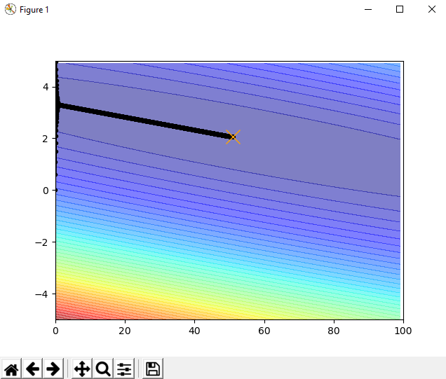

**Takeaways from this Assignment:**

1. Translating the gradient decent equation was the most difficult part of this program. This is primarily because figuring out certain aspects like where to start the model or making sure to store the previous attempts correctly and updating the model each iteration were important because the model would “glob” at the left hand side of the bowl or update in sporadic ways.
2. Tweaking the learning rate and the number of iterations produced various results. Too few iterations didn’t allow the model enough time to converge and learning rate that was too high resulted in overflow errors.
3. Don’t forget to add a “.show()” to make your graph show up